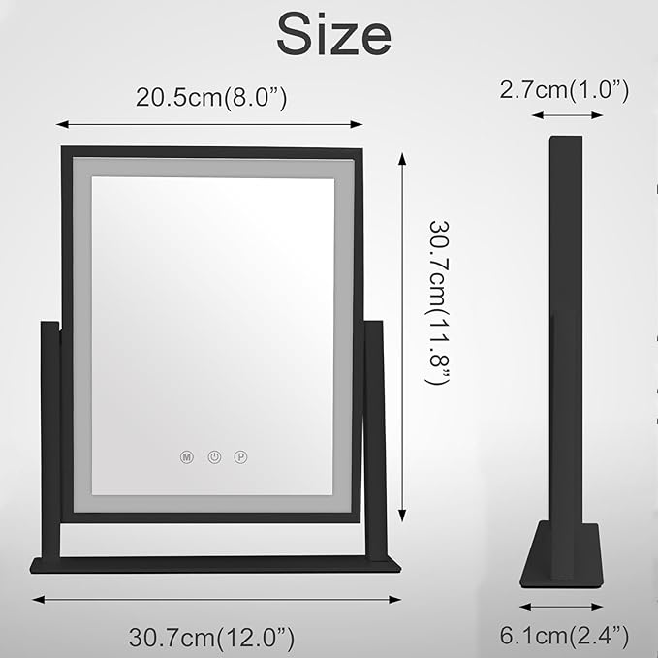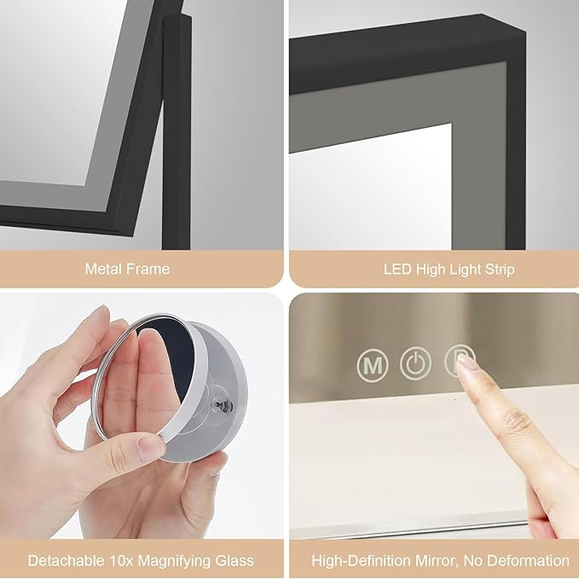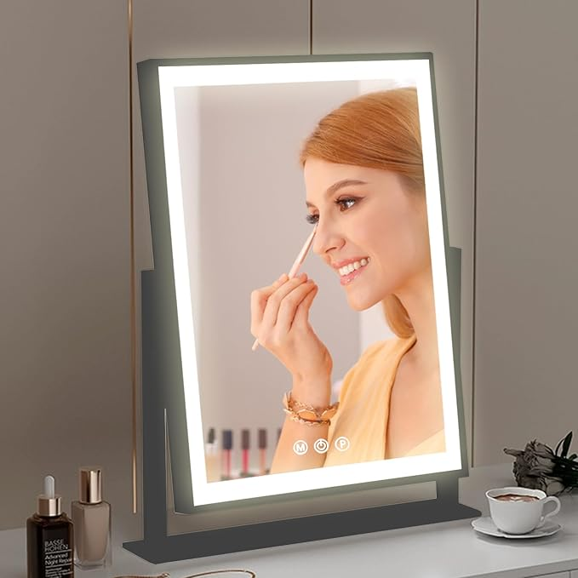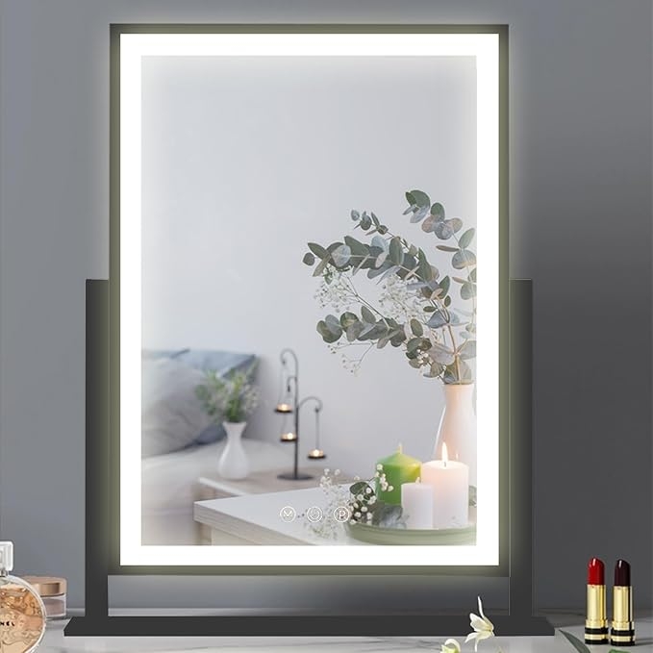

Hollywood Vanity Mirror with Lights, 360° Rotation LED Lighted Makeup Mirror, 3 Color Lighting Modes, Portable Mirror for Bedroom, Mirror with Lights for Makeup Desk ＆ Dressing Room (Black)

**PRODUCT DESCRIPTION:**

|  |  |
| --- | --- |
| Brand | KPIONT |
| Room Type | Bedroom |
| Shape | Rectangular |
| Product Dimensions | 12"L x 10"W |
| Frame Material | Alloy Steel |

**About this item**

* Adjustable Brightness and 3 Color Lighting Modes: The hollywood vanity mirror with lights comes has 3 color modes: Cool White, Warm White and Warm Yellow, which can be changed according to your needs. Adjust the mirror's brightness and change any color you like to meet your various makeup needs
* Upgrade Brightness: Most of the makeup mirror bars on the market only have few light beads, which makes consumers feel that the lighting is not enough. We have improved on this! We have a whole line of lamp beads, which greatly improving the brightness of the lighted makeup mirror. The brightness can be adjusted to meet your personal makeup needs
* Smart Touch Control and Memory Function: The buttons on the light up mirror are super sensitive and durable. Just touch the buttons on the lighted mirror screen to turn on/off the mirror's light or change the color mode, button "M" adjusts the light mode and button "P" adjusts the brightness. The memory function returns the makeup mirror to the brightness it was at before it was turned off
* 360° Free Rotation Mirror: Our portable mirror can achieve 360° free rotation and can be fixed in any position as needed. The 12-inch high x 10-inch wide lighted makeup mirror allows you to see your entire face at once, helping you to put on delicate makeup
* Premium Service: We take pride in the excellence of our craftsmanship and provide elite care to our esteemed clientele. Our illuminated mirrors have undergone rigorous evaluations, encompassing endurance, stability, and resilience assessments. Should any concerns arise with your mirror, please reach out to us without delay, and we shall ensure your utmost satisfaction